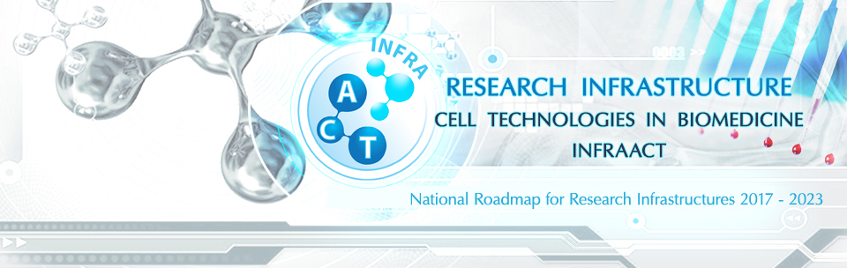

WORKSHOP
„Assisted reproduction technologies and regenerative medicine“ –
6 June 2019 from 13:00 to 14:00 h,
Meeting Hall, Faculty of Biology, Sofia University “St Kl. Ohridski
8, Dragan Tsankov Blvd, 1164 Sofia

Non confidential information
Name, Family name
Institution
Expertise in ART/stem cells
(yes/no)
Do you like to suggest topic/ask question
(yes/no)
(if yes, please specify)
Contact

Please send the completed form until 31 May 2019 to: alliancecelltechnologies@abv.bg

